16. Software Management

Tasks

1.Use the apt package manager to install the VLC media player on your Linux system, then verify the installation by running vlc --version in the terminal.

ANS:

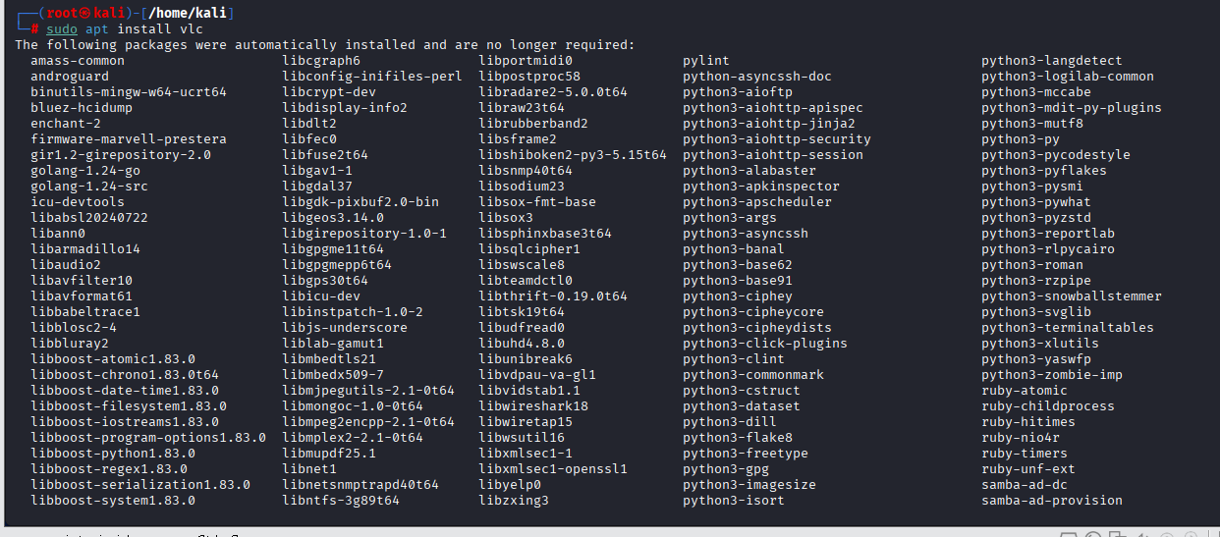

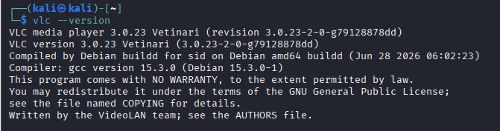

2. Update all installed packages on your Linux system using the appropriate package manager command, and take a screenshot of the output showing at least one package being upgraded.

ANS:

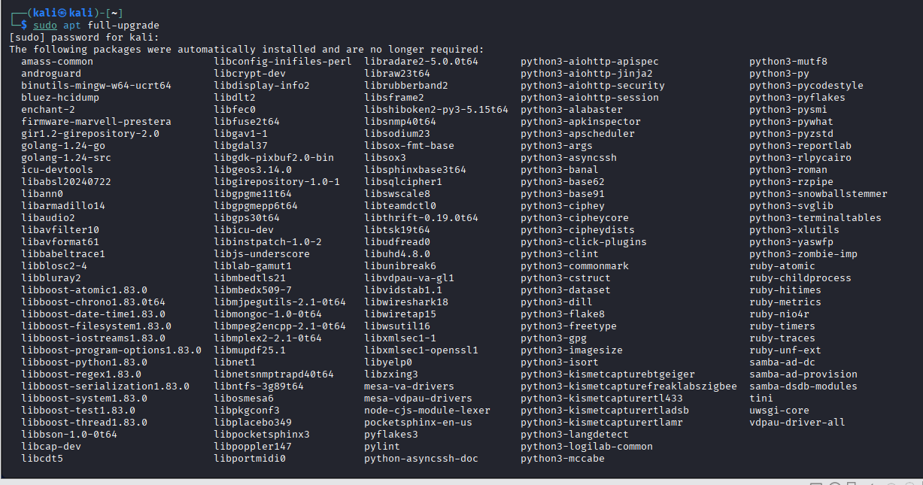

3. Remove the nano text editor from your system using the package manager, then confirm it has been removed by attempting to run nano in the terminal. Use apt remove or yum remove depending on your Linux distribution.

ANS:

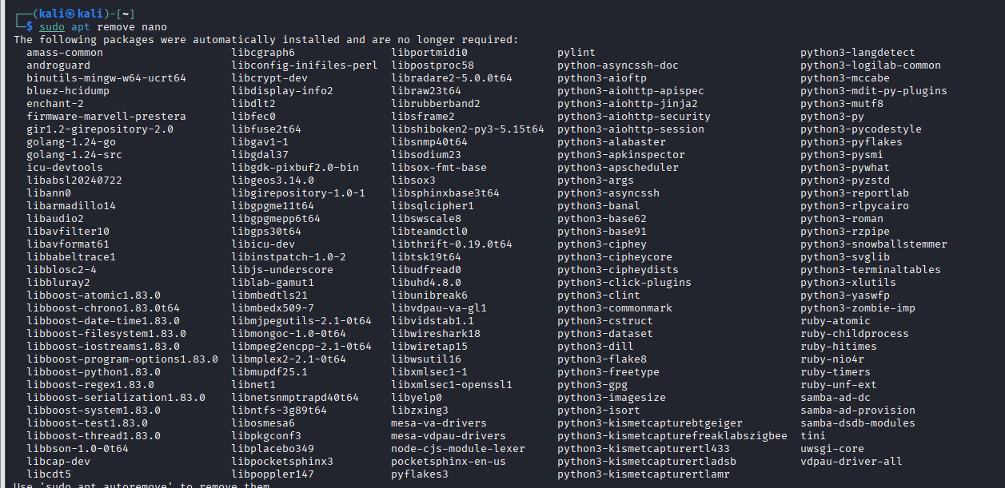

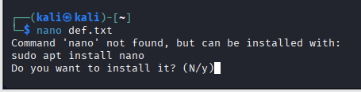
4. List all installed packages on your system and filter the results to show only packages related to 'python'. Use grep to filter the output of your package manager's list command.

ANS:

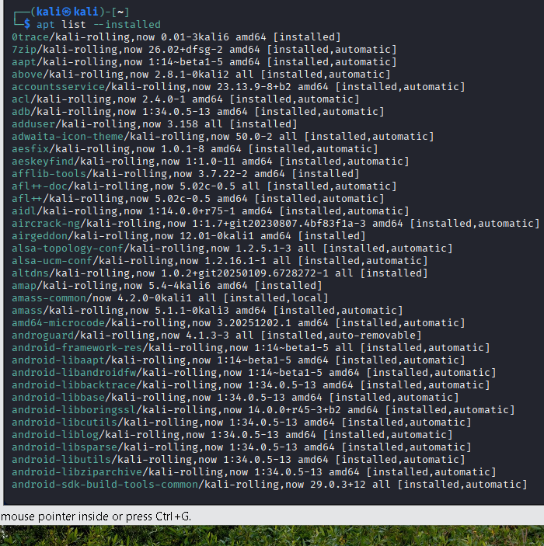

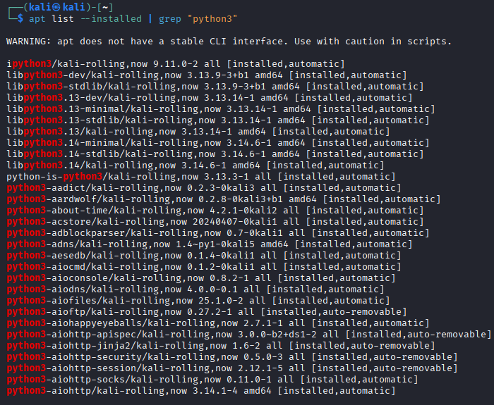

5. Use ChatGPT or Copilot to generate the command needed to clean up unused packages and dependencies on your Linux system, then run the command and share the result Ask the AI tool: 'What is the command to remove unused packages in Ubuntu/Debian?' and try it on your system.

ANS:

